MongoDB -Aggregation Exercises

Import the zips.json file into your MongoDB. Database name is "population" and collection name is "zipcodes".

mongoimport --db population --collection zipcodes --file zips.json

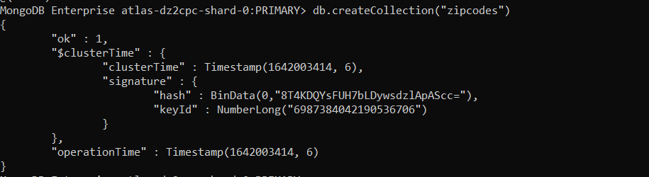

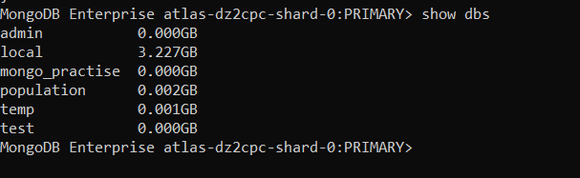

Atlanta Population

- use db.zipcodes.find() to filter results to only the results where city is ATLANTA and state is GA.

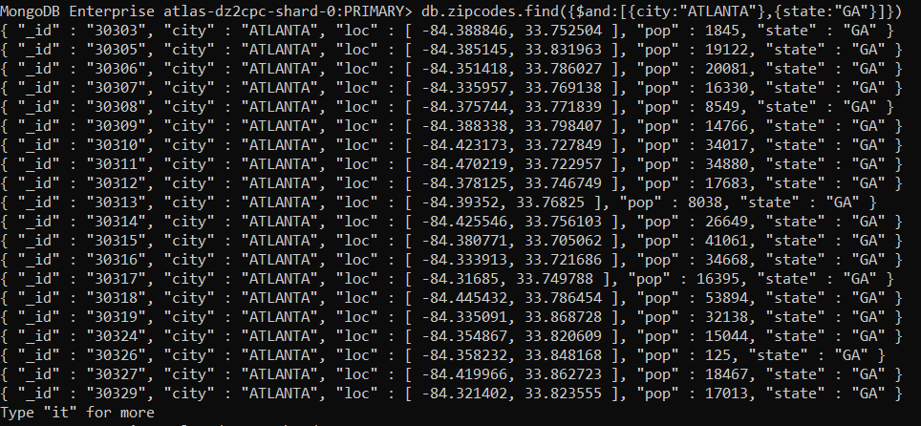

- use db.zipcodes.aggregate with $match to do the same as above.

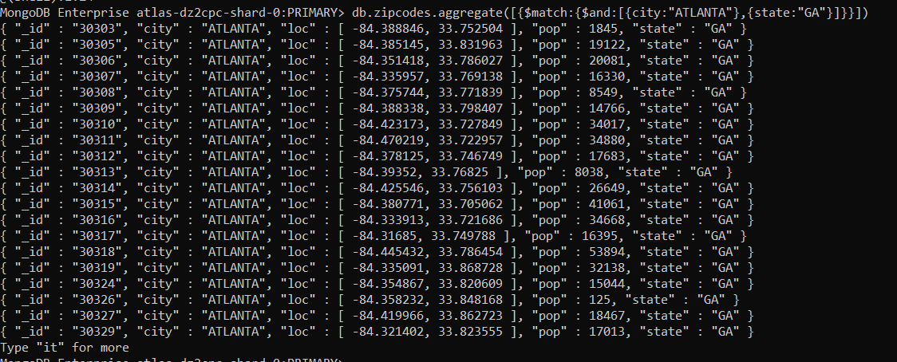

- use $group to count the number of zip codes in Atlanta
.

- use $group to find the total population in Atlanta
.

Populations By State

- use aggregate to calculate the total population for each state

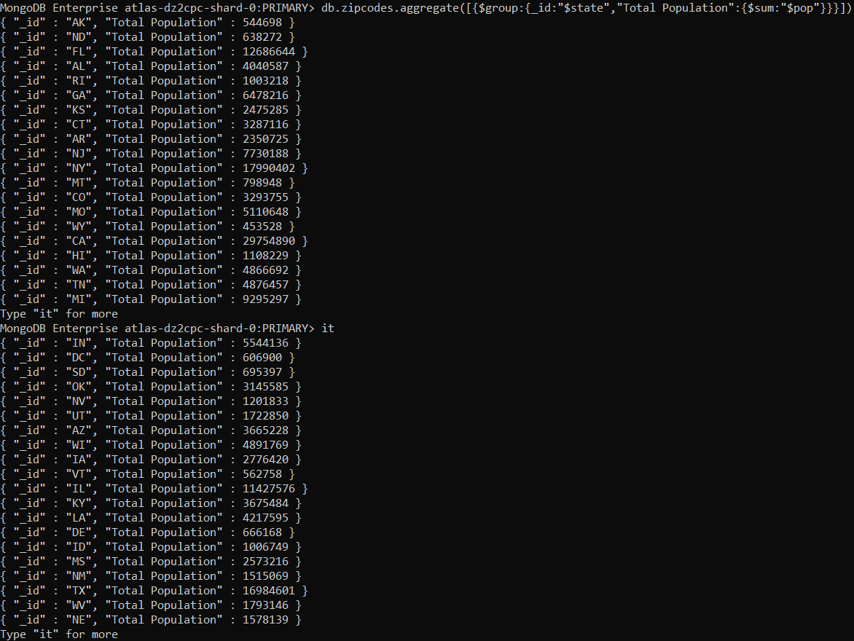

- sort the results by population, highest first

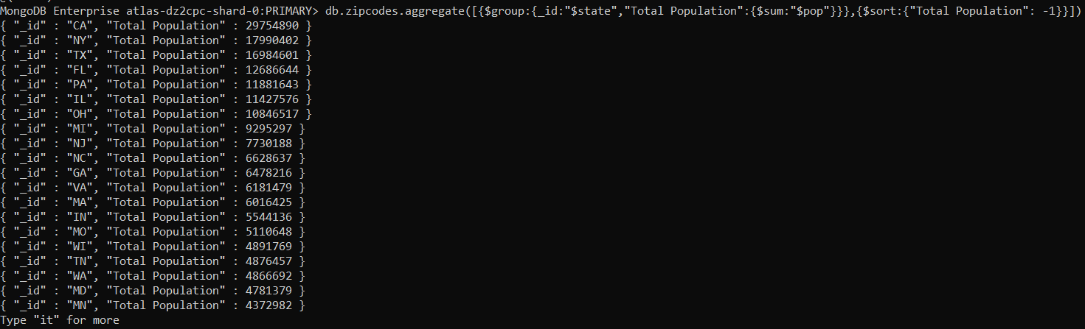

- limit the results to just the first 3 results. What are the top 3 states in population?

Populations by City

- use aggregate to calculate the total population for each city (you have to use city/state combination). You can use a combination for the _id of the $group: { city: '$city', state: '$state' }

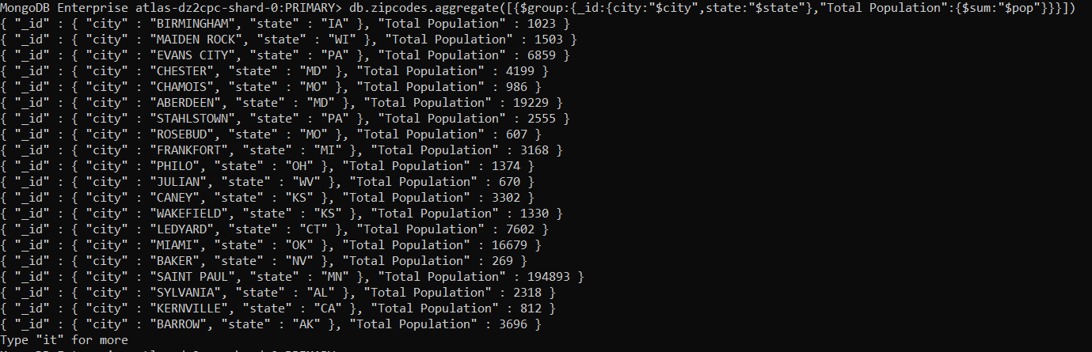

- sort the results by population, highest first

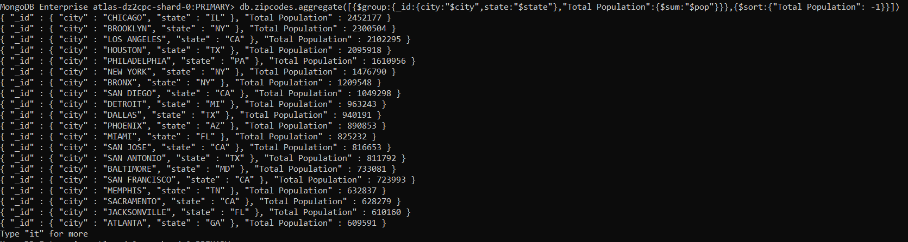

- limit the results to just the first 3 results. What are the top 3 cities in population?

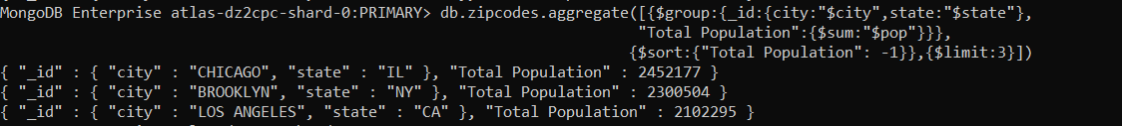

- What are the top 3 cities in population in Texas?

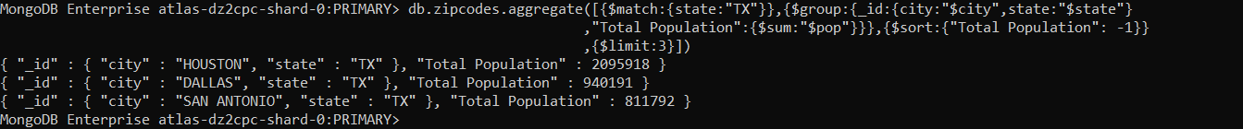

Bonus

- Write a query to get the average city population for each state.

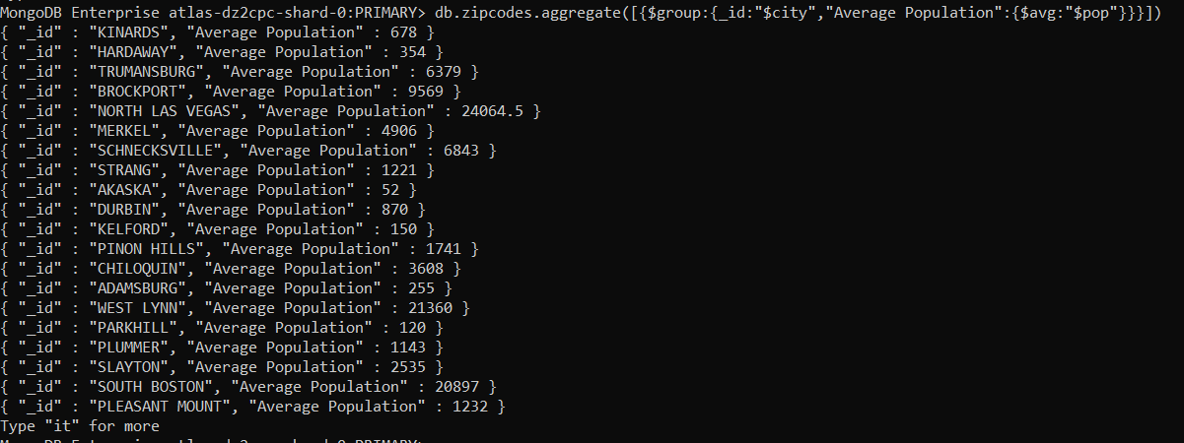

- What are the top 3 states in terms of average city population?

